Overview
This document contains intentionally reproduced Unity engine issues to aid me in understanding unity and its systems.
All issues were tested and observed using:
- Unity Version: Unity 6.3 LTS (6000.3.6f1)
- Editor Platform: Windows (DX12)
Which is the latest version of unity currently available for me to use.
Although error messages as well as engine responses may vary across different unity versions.
In each case I will focus on identifying root causes, diagnosing issues using Unity tooling and documenting correct fixes and best practices from a support engineering perspective.

Bug Case 01 – UnassignedReferenceException
Scene
01_NullReference_Bug
Issue Summary
An UnassignedReferenceException is thrown when entering Play Mode due to a missing serialized reference.
Observed Error
UnassignedReferenceException: The variable target of Bug_NullReference has not been assigned.
Diagnosis
Inspection of the Console identified the exception originating from Bug_NullReference.Start().
The public target field was not assigned in the Inspector, resulting in a null reference when attempting to access target.transform.
Root Cause
A required serialized GameObject reference was not assigned prior to runtime execution.
Resolution
A null check was added before accessing the reference to prevent runtime failure and error logging was introduced.
Best Practice / Prevention
Validate serialized fields at runtime and ensure required references are assigned via the Inspector or safely retrieved using GetComponent().
Support Engineering Insight
This represents a common Unity runtime issue encountered in projects and shows how important defensive coding and Inspector validation.

Bug Case 02 – GC Allocations Causing Frame Time Spikes
Issue Summary
A Unity scene experienced frame time spikes caused by frequent garbage collection triggered by per-frame managed allocations.
Diagnosis
Using the Unity Profiler, frames exceeding the target frame time were inspected.
The allocations and CPU views showed significant GC activity from Bug_GCAllocations.Update(), which was allocating memory every frame.
LINQ usage, array creation, string formatting and frequent logging were primary allocation sources.
Root Cause
Allocation-heavy operations were executed inside the Update() loop, resulting in continuous managed memory allocations and costly garbage collection cycles.
Resolution
Allocation-heavy constructs were removed.
LINQ was replaced with a different loop; logging frequency was reduced. Runtime profiling confirmed that GC allocations and garbage collection spikes were removed.
Verification
After resetting the Profiler and re-running the scene, GC allocations per frame dropped to zero and frame times remained consistent
Best Practice
Avoid managed allocations in places such as Update() and review performance changes using the Unity Profiler.

Script running causing error

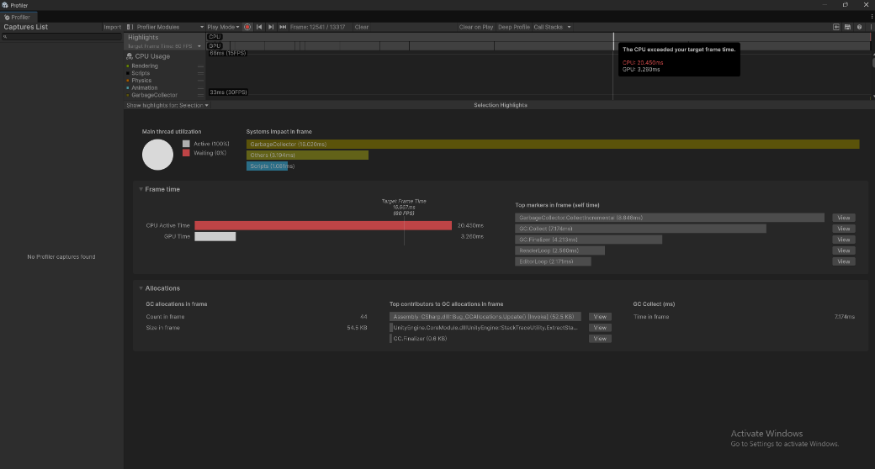

Script after changes
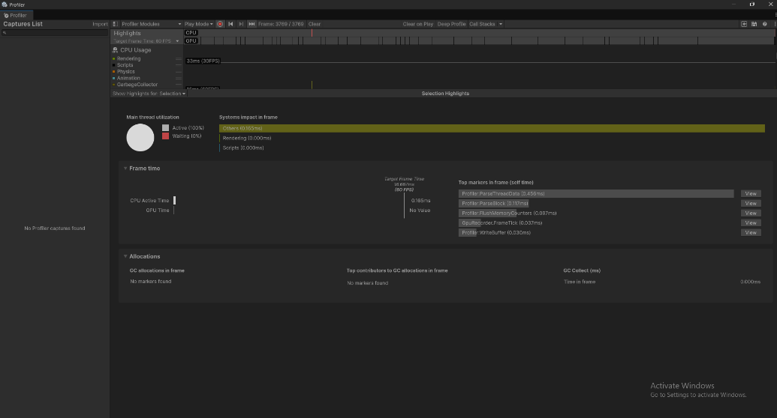

Bug Case 03 – Managed Memory Leak Due to Static Reference Retention
Scene
03_ManagedMemory_Leak
Issue Summary
Managed memory usage increased continuously over time, despite regular garbage collection activity.
Diagnosis
Using the Unity Profiler, managed heap usage was observed to steadily increase during runtime.
Garbage collection events occurred, but memory was not reclaimed, showing that allocated objects were being retained by references that were active.
Root Cause
A static collection retained references to allocated memory chunks.
This was as the collection was static, the garbage collector could not release the memory, resulting in managed memory growth over time.
Resolution
Static references were explicitly cleared during the component lifecycle by implementing cleanup logic in OnDisable(), ensuring references were released when the component or scene was deactivated.
Verification
After disabling the component at runtime, managed memory growth stopped and heap usage stabilised.
No further upward trend was observed in the Memory Profiler, confirming that retained references were successfully released.
Best Practice
Avoid long-lived static references to runtime-allocated objects unless strictly necessary.
Ensure that static collections, event subscriptions, and cached data are explicitly cleared during appropriate lifecycle events.
Support Engineering Insight
Managed memory leaks are often subtle and may not cause immediate performance issues.
Identifying sustained memory growth over time and understanding Unity’s garbage collection behaviour is critical when diagnosing long-running stability issues in customer projects.

In the image below, you can observe how the data leakage impacted memory performance; once the Clear() function is called, static references are released, allowing memory to be reclaimed and usage to stabilise.
